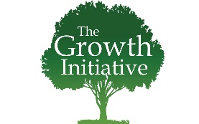
INTERPRETATION WORKSHEET #2

Text: ____________________________________________

1. Answer Questions from the Text

2. Context, Flow of Thought, & Main Point

3. Connections to Jesus

- Death and resurrection, or

- Need for repentance and forgiveness, or

- Proclamation to all nations

